Example UML Project

Project Name: Mapping Test Project

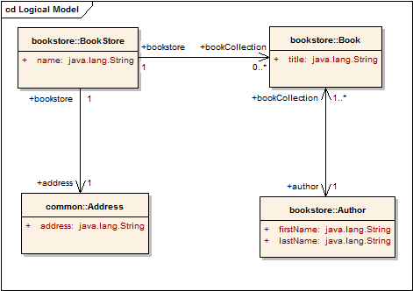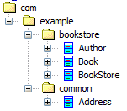

UML Profile Mappings

Project Mappings
Project maps to:
- namespace -> XMLNamespace
  - namespace=gme://example.com/version/1.0
I made up this namespace when I created the XSD. The XSD just imports the XSDs of each of the project’s packages.

Package Mappings
com.example.common Package maps to:
- namespace -> XMLNamespace
  - namespace= gme://common.example.com/version/2.5
I made up this namespace when I created the XSD.

com.example.bookstore Package maps to:
- namespace -> XMLNamespace
  - namespace= gme://bookstore.example.com/version/1.0
I made up this namespace when I created the XSD.

Class Mappings
com.example.common.Address Class maps to:
- xmlRepresentation -> XMLElement
  - name= Address
  - xmlNamespace -> XMLNamespace
    - namespace= gme://common.example.com/version/2.5

com.example.bookstore.Author Class maps to:
- xmlRepresentation -> XMLElement
  - name= Author
  - xmlNamespace -> XMLNamespace
    - namespace= gme://bookstore.example.com/version/1.0

com.example.bookstore.Book Class maps to:
- xmlRepresentation -> XMLElement
  - name= Book
  - xmlNamespace -> XMLNamespace
    - namespace= gme://bookstore.example.com/version/1.0

com.example.bookstore.BookStore Class maps to:
- xmlRepresentation -> XMLElement
  - name= BookStore
  - xmlNamespace -> XMLNamespace
    - namespace= gme://bookstore.example.com/version/1.0

Class Association Mappings
BookStore (bookstore 1…1) to Book ( bookCollection 0…*)Association maps to:
- targetXMLRepresentation -> XMLLocationReference
  - relativeXPathExpression=bookCollection/Book
  - containingElement -> XMLElement
    - name= BookStore
    - xmlNamespace -> XMLNamespace
      - namespace= gme://bookstore.example.com/version/1.0
Notice how this association is unidirectional from BookStore to Book, and the “targetXMLRepresentation” is what is populated. However, the containingElement is actually the Source. Think of the mapping representing the location of the target within the source. Also notice there is no sourceXMLRepresentation as the target does not contain a link back to the source (the association is unidirectional).

BookStore (bookstore 1…1) to Address (address 1…1)Association maps to:
- targetXMLRepresentation -> XMLLocationReference
  - relativeXPathExpression=address/Address
  - containingElement -> XMLElement
    - name= BookStore
    - xmlNamespace -> XMLNamespace
      - namespace= gme://bookstore.example.com/version/1.0

Book (bookCollection 1…*) to Author(author1…1)Association maps to:
- targetXMLRepresentation -> XMLLocationReference
  - relativeXPathExpression=author/Author
  - containingElement -> XMLElement
    - name= Book
    - xmlNamespace -> XMLNamespace
      - namespace= gme://bookstore.example.com/version/1.0
- sourceXMLRepresentation -> XMLLocationReference
  - relativeXPathExpression=bookCollection/Book
  - containingElement -> XMLElement
    - name= Author
    - xmlNamespace -> XMLNamespace
      - namespace= gme://bookstore.example.com/version/1.0

Attribute Mappings
Author firstName Attribute maps to:
- xmlRepresentation -> XMLLocationReference
  - relativeXPathExpression=@firstName
  - containingElement -> XMLElement
    - name= Author
    - xmlNamespace -> XMLNamespace
      - namespace= gme://bookstore.example.com/version/1.0

Author lastName Attribute maps to:
- xmlRepresentation -> XMLLocationReference
  - relativeXPathExpression=@lastName
  - containingElement -> XMLElement
    - name= Author
    - xmlNamespace -> XMLNamespace
      - namespace= gme://bookstore.example.com/version/1.0

Book title Attribute maps to:
- xmlRepresentation -> XMLLocationReference
  - relativeXPathExpression= title
  - containingElement -> XMLElement
    - name= Book
    - xmlNamespace -> XMLNamespace
      - namespace= gme://bookstore.example.com/version/1.0

BookStore name Attribute maps to:
- xmlRepresentation -> XMLLocationReference
  - relativeXPathExpression= name
  - containingElement -> XMLElement
    - name= BookStore
    - xmlNamespace -> XMLNamespace
      - namespace= gme://bookstore.example.com/version/1.0

Address address Attribute maps to:
- xmlRepresentation -> XMLLocationReference
  - relativeXPathExpression= address
  - containingElement -> XMLElement
    - name= Address
    - xmlNamespace -> XMLNamespace
      - namespace= gme://common.example.com/version/2.5

